Instruction for completing Sentence Forms that Contain Macros

*Note that if you are completing the Confinement only sentence sheet, a lot of the below steps will be skipped over.*

***Must import the Word Macro Customizations for Tool bar into Microsoft Word

1. Open document (the document should already be in protected/locked format)

2. Enable the Macros in the Security Warning Ribbon by selecting the Enable Contents button (yellow arrow). Newer versions of Word, may require you to select View in the top margin, then Edit document.

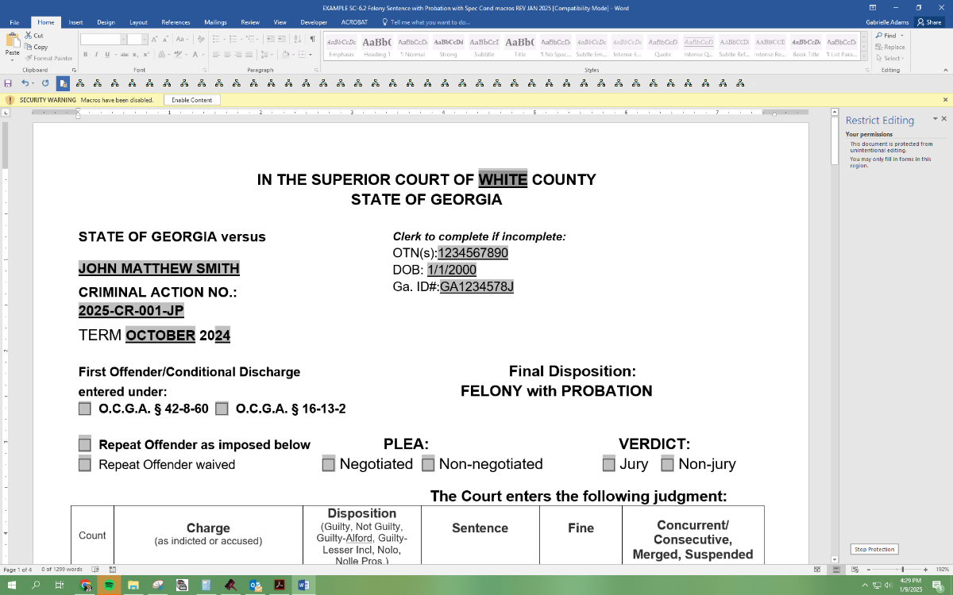

3. Insert County Name in first field (red arrow). *(This field will be referenced fields in other parts of the sentence to assist with automated entry)*

4. Tab to next field and insert defendant’s name (green arrow).

5. Tab to next field and insert case number (blue arrow).

6. Tab to next field and insert OTN number(s) that apply to counts of this case. (light green arrow) *(This field will normally contain 1 number but if you have more than 1 OTN then just space key or use the return (enter) key between the additional number(s). Form will adjust as necessary)*

7. Tab to next field and insert date of birth. (dark red arrow) *(You can type short version of DOB and field will update to 4 character year length – 1/1/70 to 1/1/1970)*

8. Tab to next field and insert GA ID# *(same as SID#)*. (orange arrow)

9. Tab to next 2 fields and insert Court term (purple arrow). *(You can modify and add a drop-down box properties to add your term months)*

10. Tab thru next check mark boxes and make appropriate selections. (pink arrows) *(Hint: Instead of taking hands off keyboard, you can hit the space bar to select and unselect the boxes and just tab thru the box to skip to next one. Tabs go line by line left to right)*

You are now ready to complete the ‘Charge Section’.

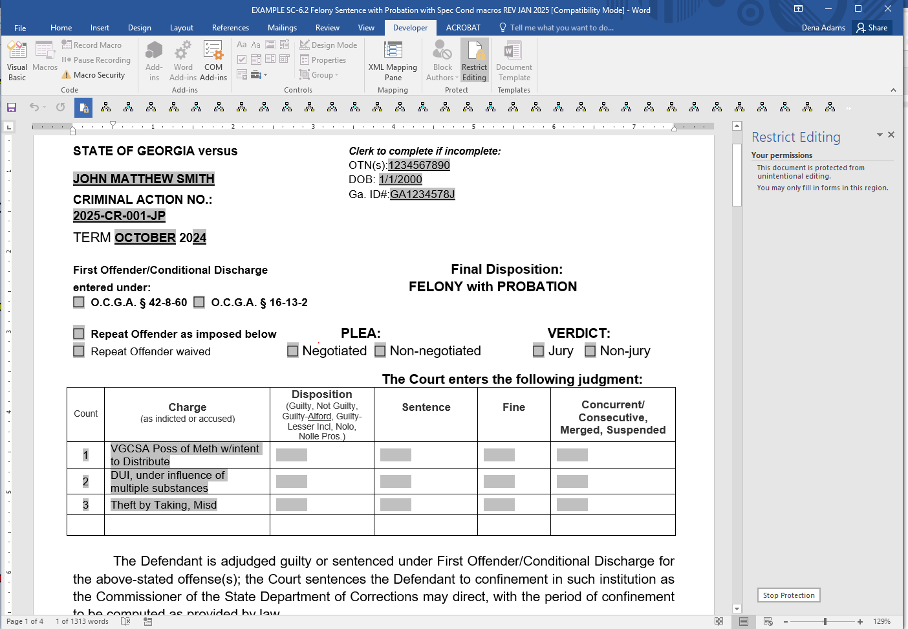

11. Tab to the 1st Charge section, then enter the count # and charge/offense exactly as listed on the Indictment or Accusation. (red arrow)

12. Complete the remaining sections of the table with the appropriate information using the following method. *(Please note the above example is only to give you an example of how the sections are used and may not be really appropriate for that charge.)*

a) Tab across the columns of the table and enter appropriate information. When you reach the end of the row and tab again it will wrap around to the 2nd row, etc. *(When preparing the sentence in open court, complete the offense charges and sentence recommendation while the DA is announcing the plea offer. When the Judge orders the sentence, you then can go back and adjust the disposition, sentence, fine, etc. to exactly as the judge states it.)*

d) You can use the copy and paste functions in this table to enter repeat information between the different charges instead of having to type the same words over and over.

c) To expand this table in order to enter additional charges, you will need to unprotect/unlock the form when you get to the last field in the charge section.

*(Follow step 13 only when necessary to add more charge fields and to enter special probation conditions covered in later steps)*

13. Unlock/Unprotect the form by any of the following methods:

a) Using any of Protect/Unprotect Document buttons that you may have added to your Quick Access Toolbar. (yellow arrow)

b) Open Developer tab in the Ribbon, select Protect Document, then select Restrict Formatting and Editing. A window should open on the left side of the computer screen. At the bottom of that box, select the Stop Protection button. (orange arrow)

c) You are now ready to add additional charge lines. Just tab at the end of the last row (blue arrow) and it will insert a new row. Type the next count # and continue to tab thru fields entering all appropriate information and adding additional lines as necessary. (green arrow)

d) If you wish to remove charge lines that are not needed (*or added by accident*), highlight the complete row (*don’t go past last field*) then right click your mouse to pull up edit box, then click to delete cells, then click to delete entire row.

**IMPORTANT! You must lock/protect the document before continuing to complete the remaining portions of the sentence.**

14. When protecting the form, verify section 2 of the Restrict Formatting to the left of the screen has to block check mark and option of ‘Filing in forms’ . (red arrow) Then select ‘Yes, Start Enforcing Protection’. The form is now locked and you will be able to tab to next form field.

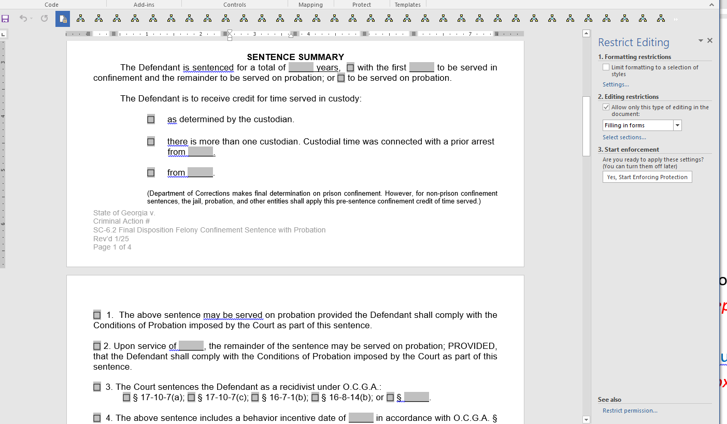

15. Continue using the Tab key through the fields and enter the summary (grand total) of the sentences for all counts (green arrow)and the appropriate option of the credit for time serve. *(This section is what Dept of Corrections is looking at for prison sentence.)*

16. Continue using the Tab key to make appropriate selections and complete the service section. (blue arrow) *(Hint: Instead of taking hands off keyboard, you can hit the space bar to select and unselect the boxes and just tab thru the box to skip to next one)*

a) Section #1, is be selected only if the sentence was given straight probation.

b) Section #2, it is very important to identify each count that was given a confinement sentence. *(Superior Court Clerks must have the break-down in order to correctly enter the disposition of each separate count into the case management and report to the GA Crime Information Center, Dept of Driver’s Service, and any other appropriate agency.)*

c) Section #3 will only be completed, if the Judge declares and orders the defendant be sentenced as a recidivist.

17. Continue to use the tab key to complete all appropriate fields in the FINE SURCHARGES or Add-ONs section *(image below)*. (red arrow below)

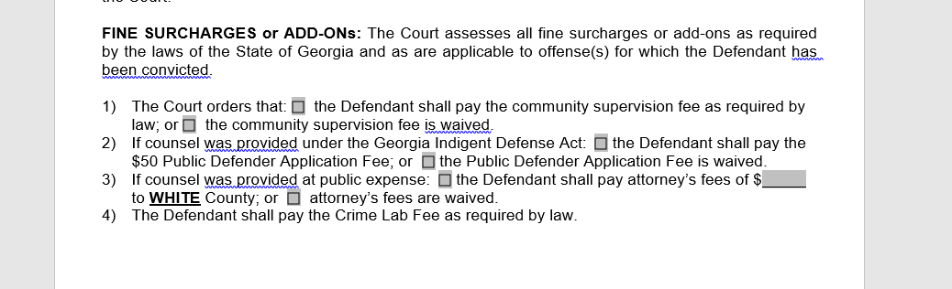

**In the next section, you are now ready to unlock/unprotect the form and use the macro function to import the Special Conditions of probation using the approved language of the additional special conditions taken from ‘Form SC-6.4(B) Inventory of Special condition’. This will reduce the number of pages used for each sentence and will keep the sentence sheet looking professional and easy to read.**  *To assist the person writing the sentence and to speed up the time required to complete the sentence form, the District Attorney’s office and Judge must identify the special conditions by their number when the negotiated plea offer or plea recommendation is stated and the sentence is ordered. Also the specifics as to certain conditions must be orally stated so that appropriate boxes can be checked and detail information added to the form fields.*

18. Unlock/Unprotect the form using the same procedure you used in step 13.

19. Use your mouse pointer to place your cursor in the line under and directly beneath the ‘l’ in the word ‘follows’ (yellow arrow) *(Don’t forget to right click the mouse to set the cursor there.)*

**You are now ready to run macros to import the additional special conditions in Section/Condition #5.**

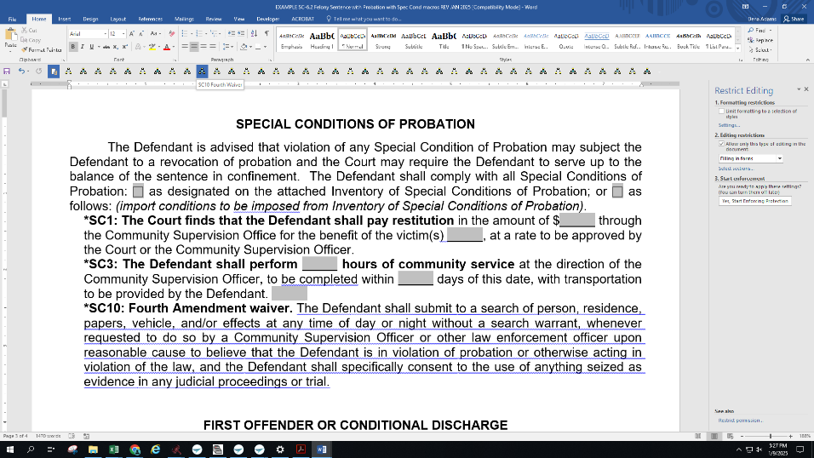

20. As the judge orders the Special Conditions, simple move your mouse pointer across the macro buttons in the Quick Access Toolbar (red arrow) and click the appropriate buttons for the macros to run and the special conditions will be inserted in the body of the sentence. (blue bracket) As you move the mouse pointer over the buttons, the name of each macro with pop up with the Special Condition # and short description will appear. (orange arrow) *(The macro buttons are in numeric order left to right)* If you accidently insert a wrong special condition, simply use your mouse to highlight/select the incorrect condition and press the delete key. Make sure that under the Home Tab in the Ribbon that the Bold button is not highlighted before inserting your next condition. (green arrow). *Suggestion: Save a version of the sentence form that contains all standard special Conditions that your Court normally sentences. You can then add and remove conditions that vary between types of sentences based on the offenses.*

**IMPORTANT! You must lock/protect the document before continue to next step. Use the same procedure as step #14.**

21. Now that the sentence form is locked again, place your mouse cursor in the first fill-in the blank or box field of the ‘Special Conditions’ that you just inserted so you can complete the details of those conditions. (purple arrow) The Other Special Condition macro (following #33) is where you will place any additional special condition of probation that the judge orders that may not be one of the 33 preset conditions.

Community Supervision and Probation offices needs the break-down of restitution of each count for collection and disbursement purpose. *Superior Court Clerks must have the break-down in order to correctly enter the restitution & community service of each separate count into the case management and report to the GA Crime Information Center and any other appropriate agency.)*

22. Continue with the tab key to complete the rest of the form fields. *(You can modify the form field to a drop-down box properties to modify Judges’ names for your circuit)*

**IMPORTANT! You must unlock/unprotect the document before continue to next step. Use the same procedure as step #13.**

23. Continue to the addendum page that has been added to assist the Community Supervision/Probation Officer and Clerk in calculation of the fines, court cost and surcharges. *(Please note that the addendum page is not part of the original Supreme Court approved form and should be approved by your court. Or you may wish to delete it from part of the sentence sheet and determine an alternative method between the Clerk and Probation Officer to insure proper collection of fine and surcharges are applied.)* This is an excel table inserted into the Word Document and requires you to unlock the form and double click the table to open the excel table. This excel table has all the fields locked except those that require information to be entered and has been set up with formulas that calculate the surcharges based on the crime date (green arrow) and type of offense (red arrow) for the fine (see code table below). You will identify the count #s (blue arrow) to only reflect the counts of the sentence that had fines ordered. If your court does not order court cost, then enter 0 in that field. The surcharges will automatically calculate when the crime date, offense code, and fine amount are entered. You will need to manually enter the Crime Lab fee (purple arrow) that pertains to all felony ($50) and only to misdemeanor cases for DUI & Misd VGCSA ($25). The fine totals per count and the grand total to the Clerk will automatically calculate.

Offense code = type of offense that require certain surcharges

V VGCSA - DATE surcharge offenses

D DUI - multiple applicable surcharges

T Traffic – DETF surcharges (Different percentages are calculated based on crime date. The original 5% surcharge time period has not been included in this formula. Should you have a case with offense date that the surcharge should be 5% then unlock the excel table and override the formula)

R Reckless Driving - multiple applicable surcharges

S SAFE Harbor Fund offense

(blank) Leave blank for all other offenses)

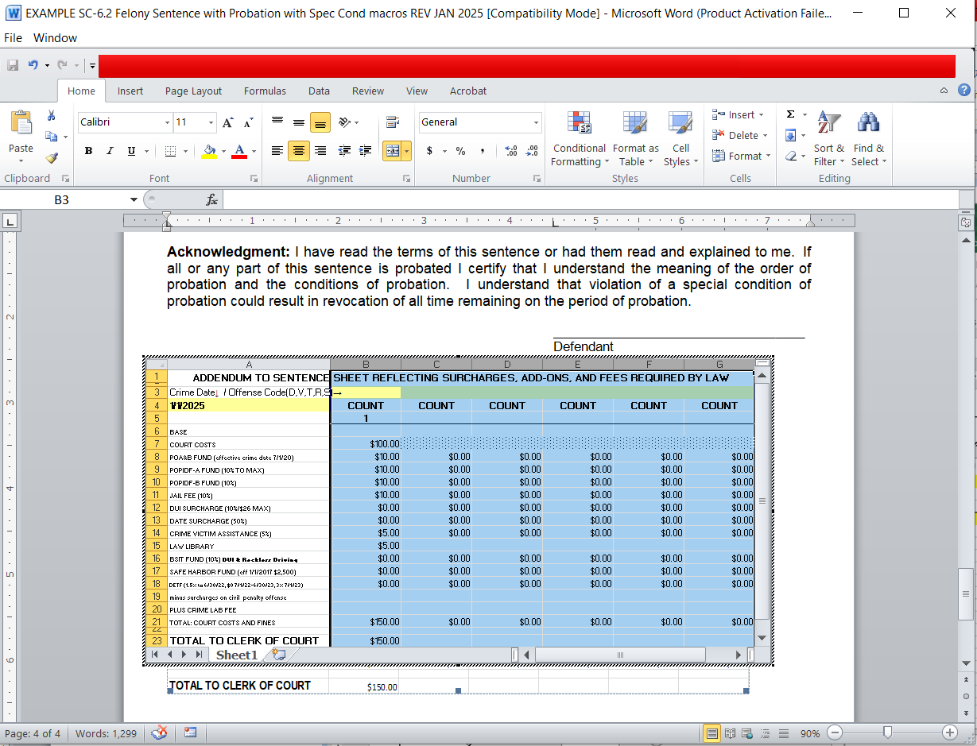

**IMPORTANT! You must lock/protect the document before continuing to next step. Use the same procedure as step #14.**

25. LAST STEP, Print the complete sentence sheet. When the print command is given, the footer sections of all the pages will update with the current case information. (green arrow)

